User Manual for ATO Editor

The ATO editor is very user friendly and provides the user with many functionalities. One of the most important functionality is that it helps the user to browse through the entire information that is present in the database in the form of a tree structure. It allows the user to perform operations like Search, find Next, Undo, Redo, Load, etc. The basic editor looks like the one the one below.

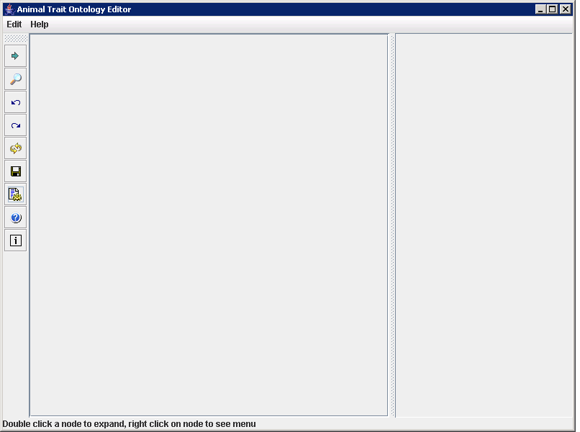
Figure 1

When the user clicks the settings tab, a dialog box pops up as in the figure below asking the user to connect to the database he wants to. It asks the user to select the database type from a combo box with the database options as MYSQL, POSTGRESQL,ORACLE. Depending on the database selected the JDBC driver gets set in the field. The user is supposed to enter url in the DB Machine URL field. Then finally, the user is supposed to enter the UserID and Password in the corresponding fields. These settings can be saved for later use by clicking the “Save Setting” button. To connect to the database the user has to click the “Test Connection” button.

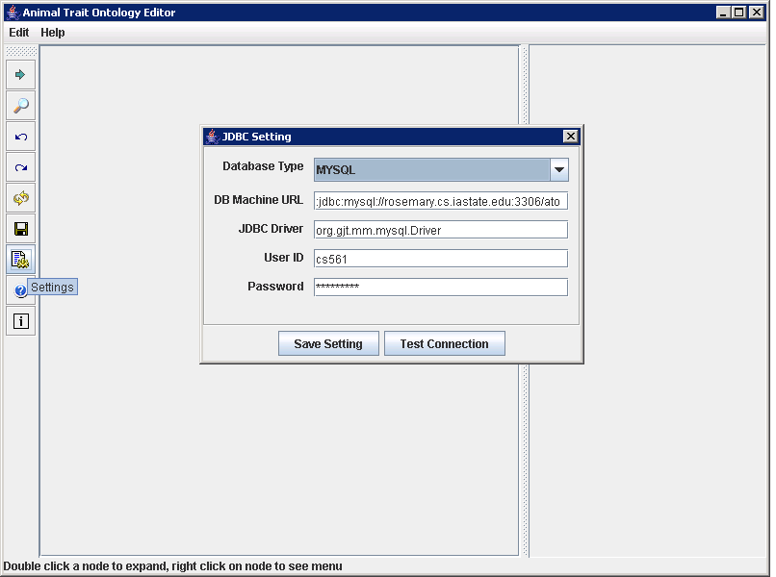
Figure 2
When the user enters the wrong values in the fields, a message box pops up which says “Given data source is NOT connectable”.

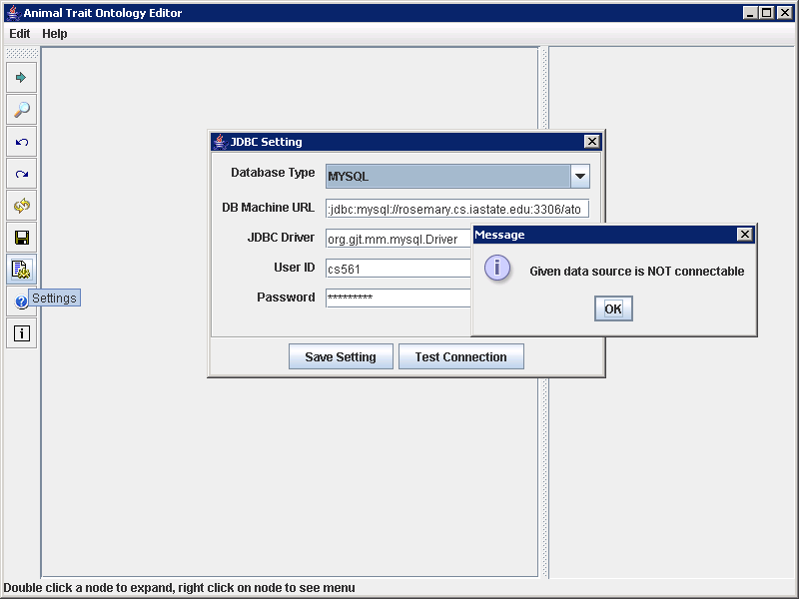
Figure 3

When user enters the correct data, we get connected to the database and the information in the database is displayed in the form of a tree with the root as ATO and its immediate children which are the names of the species. The resultant screen looks like the one in the figure below. The database at present has only one species which is sus scrofa and the other name of the species shown in the snapshot is a dummy one.

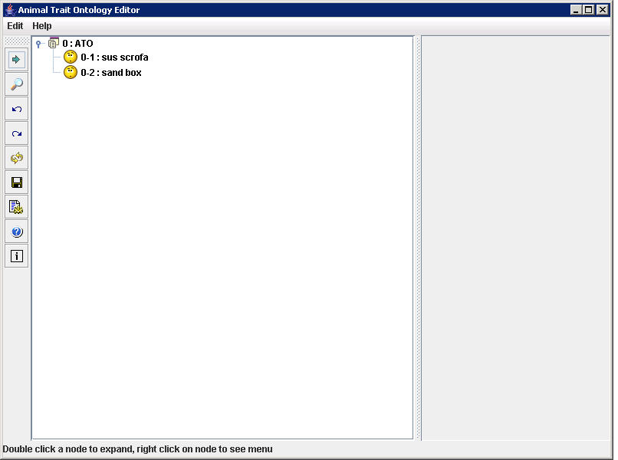
Figure 4

The ATO editor has some tabs at the left most corner which give the user with the ability to perform some function. We now explain the functions that are enabled by the tabs

This tab is used for expanding the node. Whenever the user selects a node and then clicks the expand tab the immediate children of the node are shown in the tabbed pane which contains the tree structure.

This symbol is for the user to perform the search operation. When ever user clicks the search symbol a dialog box shown below appears which asks the user to enter the term he wants to search for.

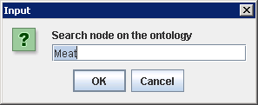
The dialog box asks the user to enter the term to be searched for.

This button helps the user to undo the changes made to a node at a previous instance of time.

This button helps the user redo the changes if the user has made changes to the node after he had changed the node once.

This is the Reload button whenever the user wants to reload the tree from the database he clicks this button and then the information form the database is retrieved and is presented in the form of a tree.

This is the save button, if the user has made any changes in the tree structure by adding, deleting or renaming a node, the changes are not reflected to the database until the user presses the save button.

This is called the Settings button, by clicking this the user can connect to the database of his choice.

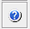 This is the help button. Whenever the user presses the help button a message box pops up which gives the information about the servers to which we can get connected to.

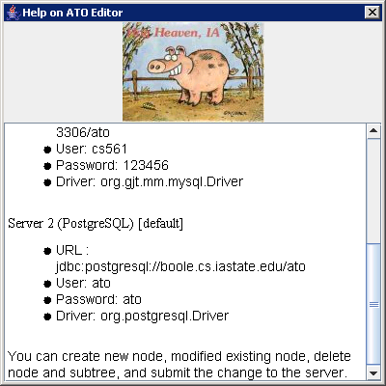

 This is the about button and gives the information regarding the version and author of ATO editor

Whenever the user selects one of the child node by left clicking on the node the details regarding the node are displayed in the tabbed pane on the right. The tabbed pane on the right contains the information such as the ID, Name, Domain of the trait and it also contains the information regarding the number of children for the trait.

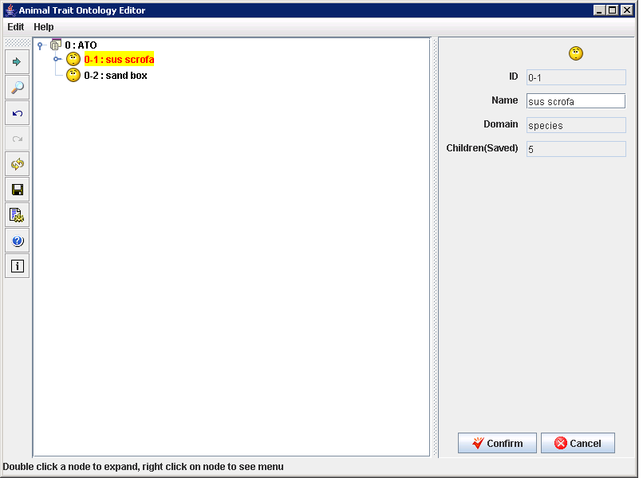
Figure 5

Whenever the user double clicks the node or selects the Expand button the node gets expanded displaying all the children corresponding to the node. Once the node is selected and the children of the node are displayed the color of the node changes red.

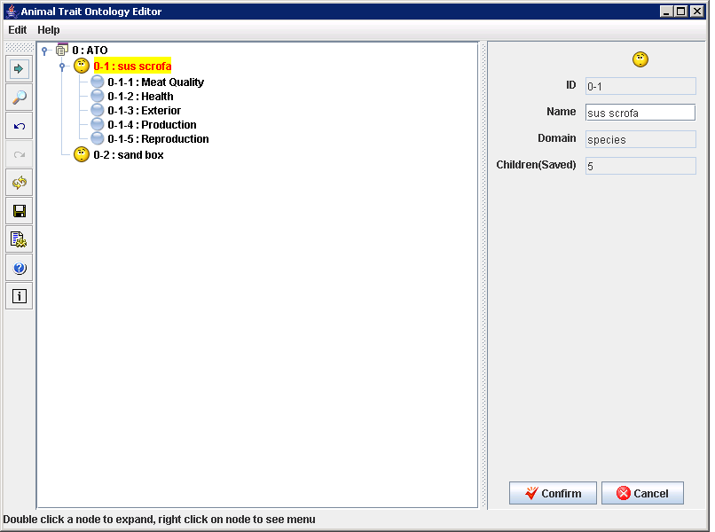
Figure 6

Whenever the user right clicks on a node a dialog box pops up gives the user various option which help the user edit the tree, there by helps the user to make changes to the database.

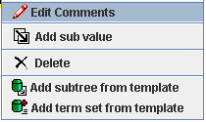
Figure 7
When the user right clicks on a node and selects the Edit Comments option a small dialog box appears asking the user to give the comment for the corresponding node. For example in the figure below appears when the user right clicks on the node “sand box”, now the user is allowed to enter a text in the text box after the user enters a text in the text field and clicks the OK button the value of the node “sand box” in the tree changes to the text value given in the text field. The changes to the tree are also made by changing the value of the node in the text fields that appears in the right tabbed pane.

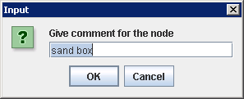

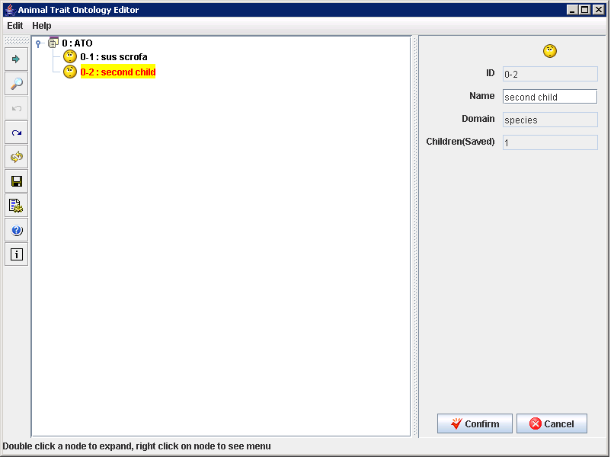

In the figure above the value of the node sand box is changed to “second child”. This is the text the user entered in the text field in the above dialog box. Now when the user selects the node “second child” and right clicks on the node again the menu appears with an added option giving the user with the facility to undo the changes. If the user selects the undo option the change made to the node will be undo and the old tree is retained.
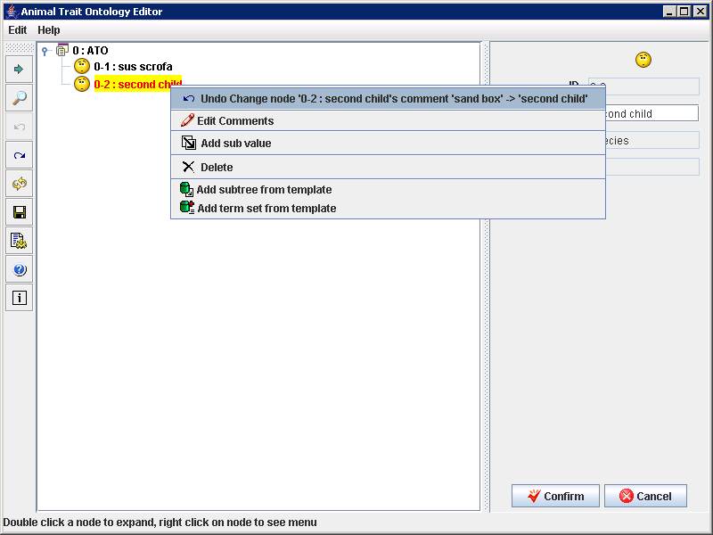

When the user has undo the change in the above example the value of the tree node would be again set to “sand box”, if the user right clicks on this node again the menu appears with a changed option asking the user if he wants to redo the changes done to the node so as to rename the node to “second child”.

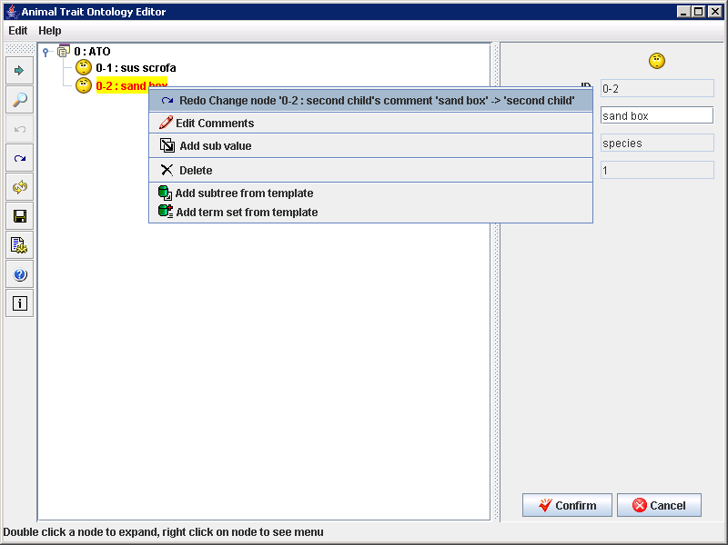
When the user selects the “Add Sub Value” option from the menu, a dialog box pops up asking the user to enter the value of the id for the new node to be added to the selected node.
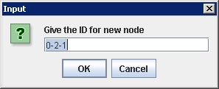
In the example here the user has selected the node with id 0-2 which has 1 child whose id is 0-2-1, therefore the dialog box also shows the next possible value of the id. When the user clicks “OK”, a new node gets added to the tree with its id value as 0-2-1 and the name of the node is set to “class” as default.
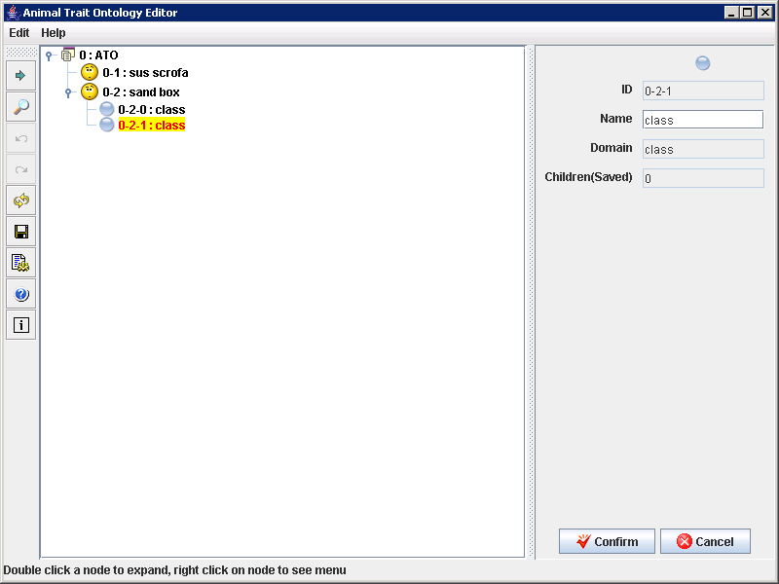

Since the update has not been made to the database the color of the node is red.

The next option for the user in the pop-up menu is the “Delete” option. When the user right clicks on a node and selects the “Delete” option, the color of the node changes to gray indicating that the node has been deleted.

In the snapshot below the user has selected the delete option for the node with ID 0-2-1,and it is seen here that the color of the node has been changed to gray.

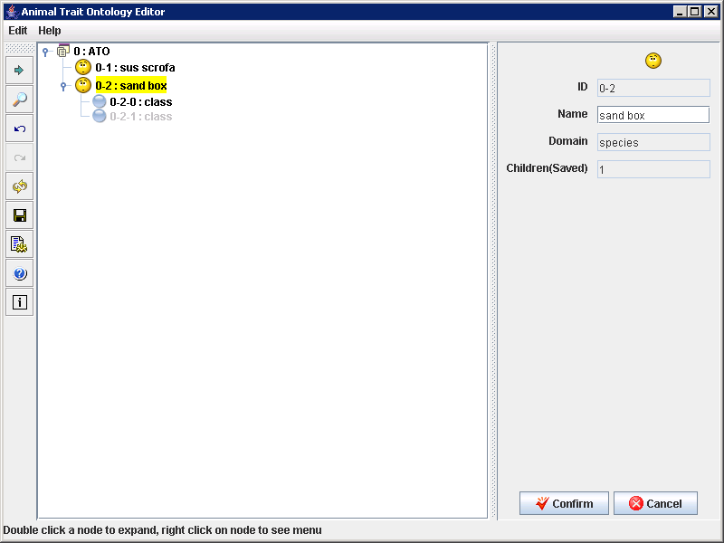

Whenever the user right clicks on a node and selects the “Add Sub tree from template” option, a dialog box appears as shown below. This option helps the user to retrieve the entire sub tree of the node with the id given in the dialog box.

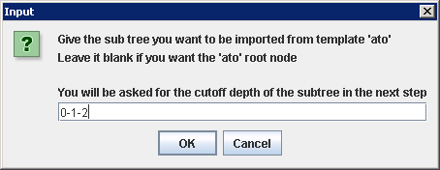

The dialog box asks the user to enter the id of the node for which the user wants to retrieve the sub tree. When the user presses the OK button in the above dialog box another dialog box appears asking the user to choose the depth of the sub tree.

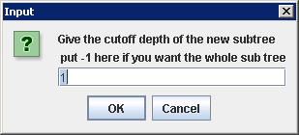
When the user presses OK in the above dialog box the entire sub tree gets displayed.

The ATO editor described above gives the user with many options to make changes to the data which is shown as a tree here in the editor. The editor is very user friendly and allows the user to perform operation like adding, deleting, renaming nodes and it also allows the user to perform search.

